**Project Tracker Application**

This is a web application specifically built to manage the operations of any given project thus from the time the project was started to the end it was completed. The application is made of the following modules

* Users
* Projects
* Tasks
* Chat

Below are explanations of how the modules work with their attached pictures:

How to get access to the web application:

Location (Office building and also using the office’s network(**WHITEWHEEL**)

Step 1: Type/copy and paste this url (**192.168.1.195:84/project_tracker/**) into any web browser:

Below is the screenshot for the landing interface after entering the url into any web browser

**Screenshot for the Landing page’s interface:**

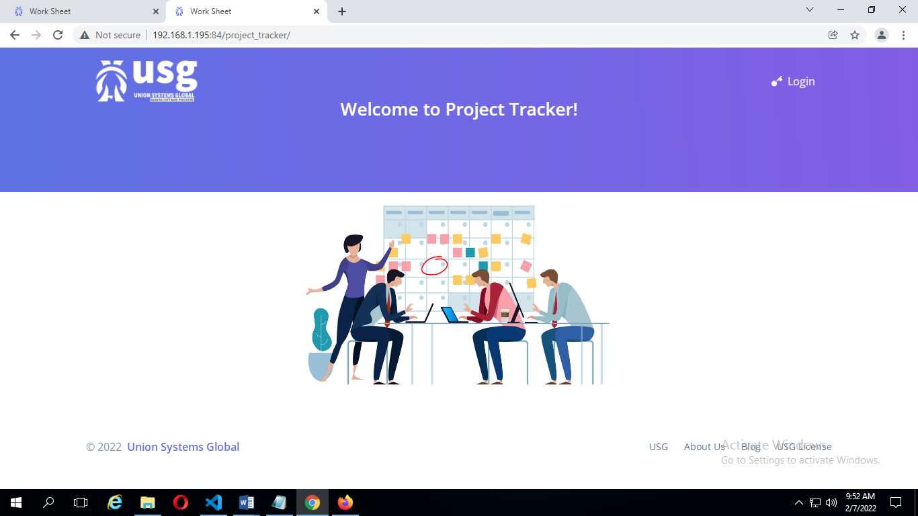

Step 2: Click on the login text. Below is the login interface after pressing the login text:

**Screenshot for the login interface:**

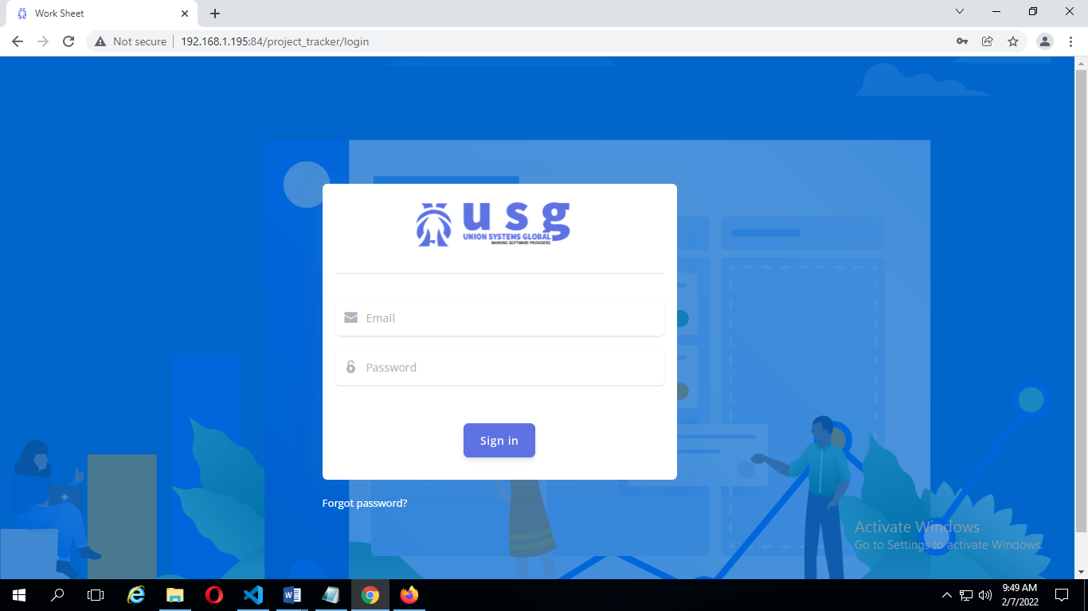

(This is for those who have logged in before and have forgotten their password):

Step 1: Click on the forgot password text:

Below is the screenshot for the forgot password page:

**Screenshot for forgot password page:**

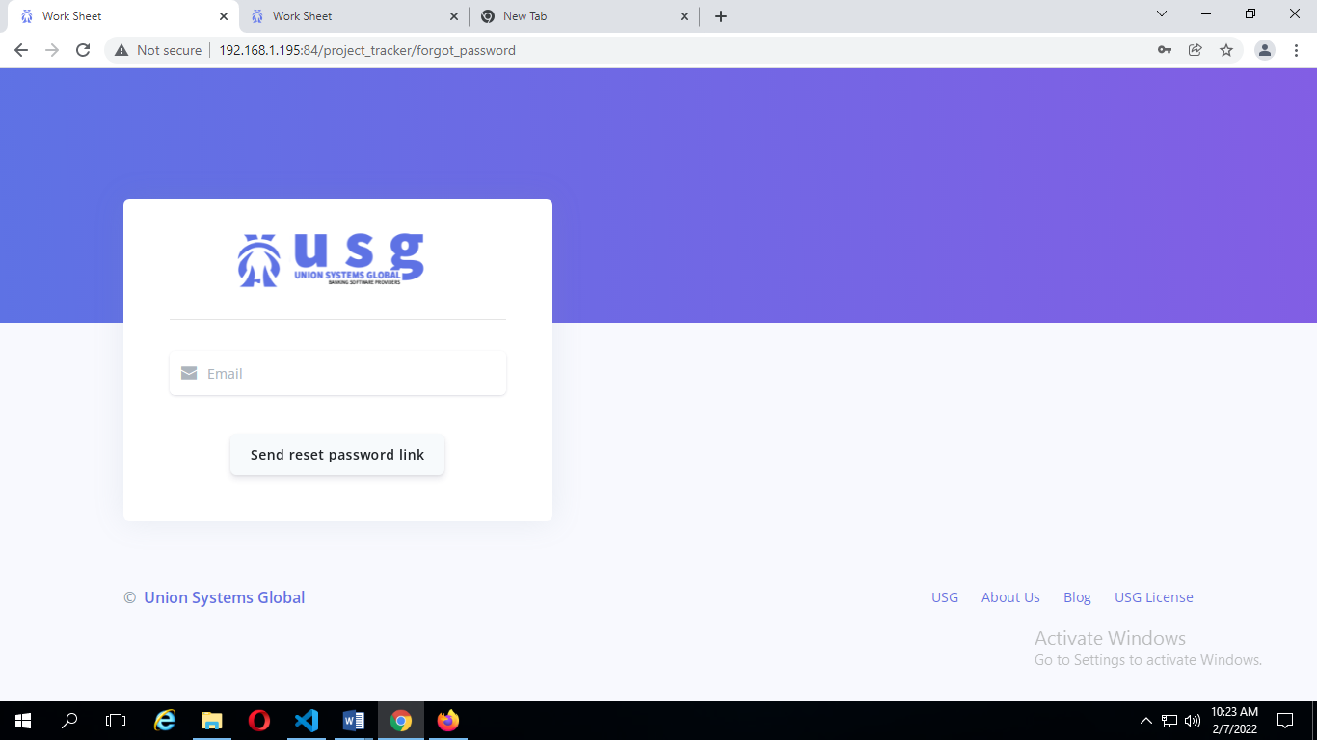

Step 2: After the email has been entered in the Email textbox, a mail is sent to the email address entered thus if the email is found in the database. The mail sent contains the reset password link. Below is the screenshot that comes after a mail as been sent to the valid email address:

**Screenshot of after mail has been sent:**

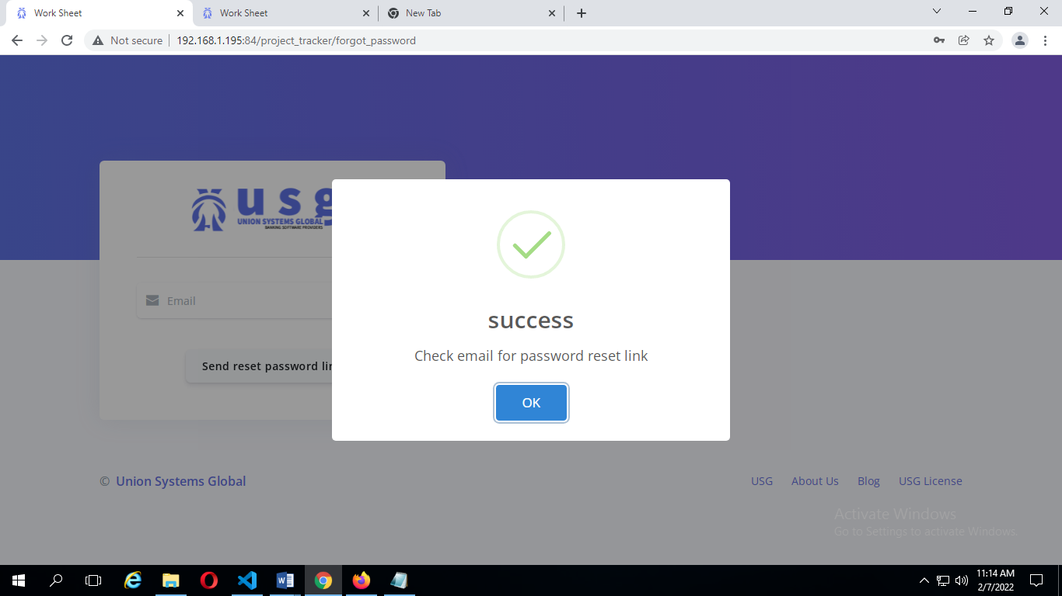

Below is the rest password page after the password reset link has been pasted in the web browser:

**Screenshot for password rest page:**

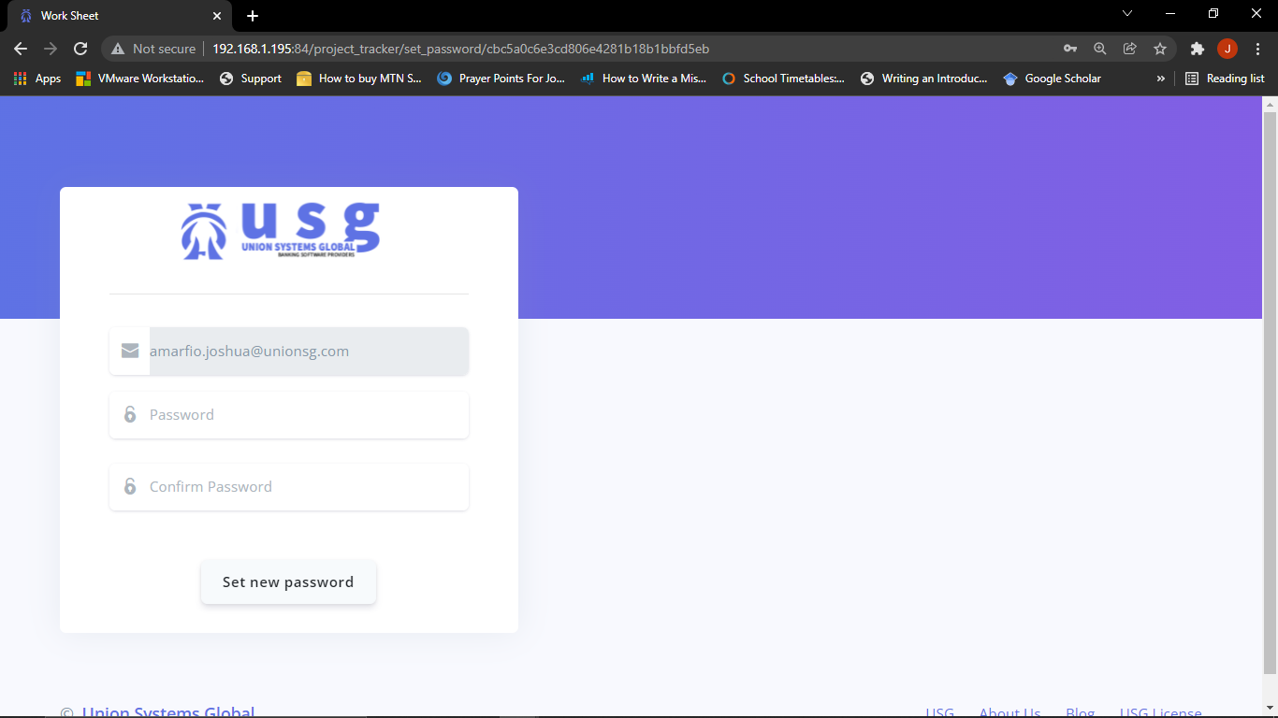

* Users: This module is mainly about the employees of the organization in this case USG (Union Systems Global). This module can be used to create, view and update user details which can only be done the admin of the application. The users module also has its types as well, which includes the assigner, the developer, and a guest.

Below are the screenshots of each user and their functionalities in the application:

**The asigner:** This user has the ability to create projects in the application and also assign developers to each project created. The screenshot below is the dashboard of the assigner.

**Screenshot for the assigner’s dashboard:**

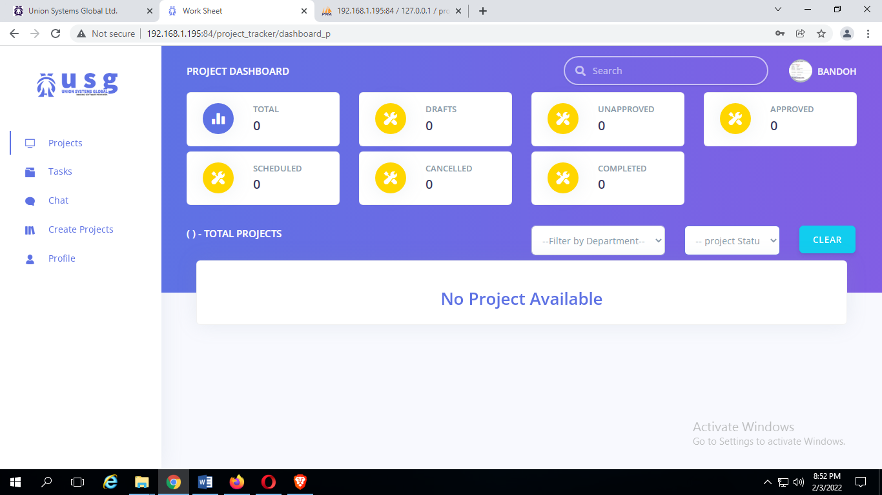

**Screenshot for project creation by the assigner**:

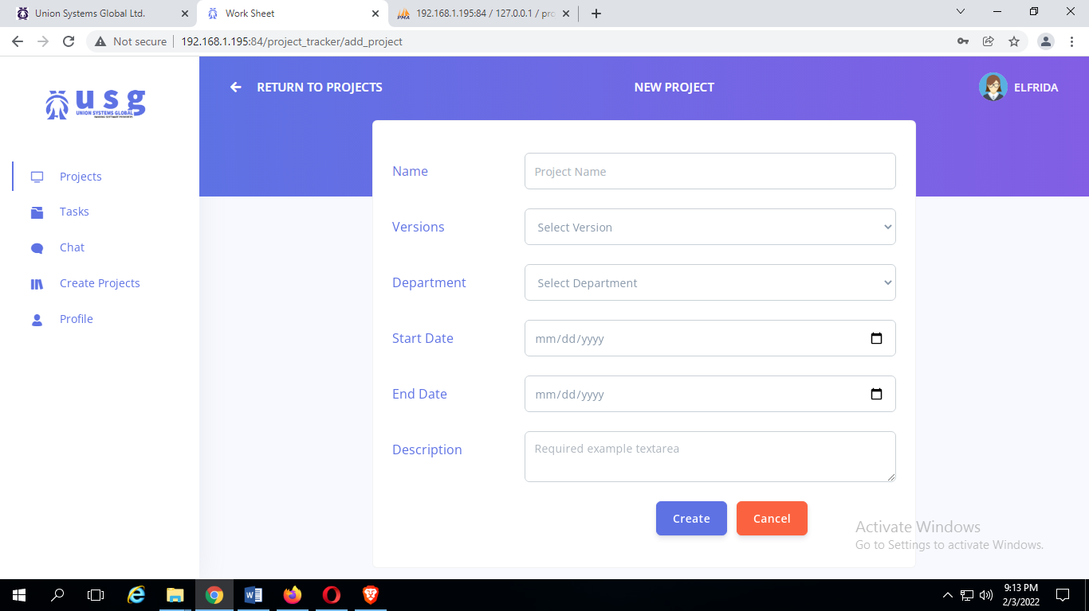

**Screenshot for the task creation by assigner after project has been created.**

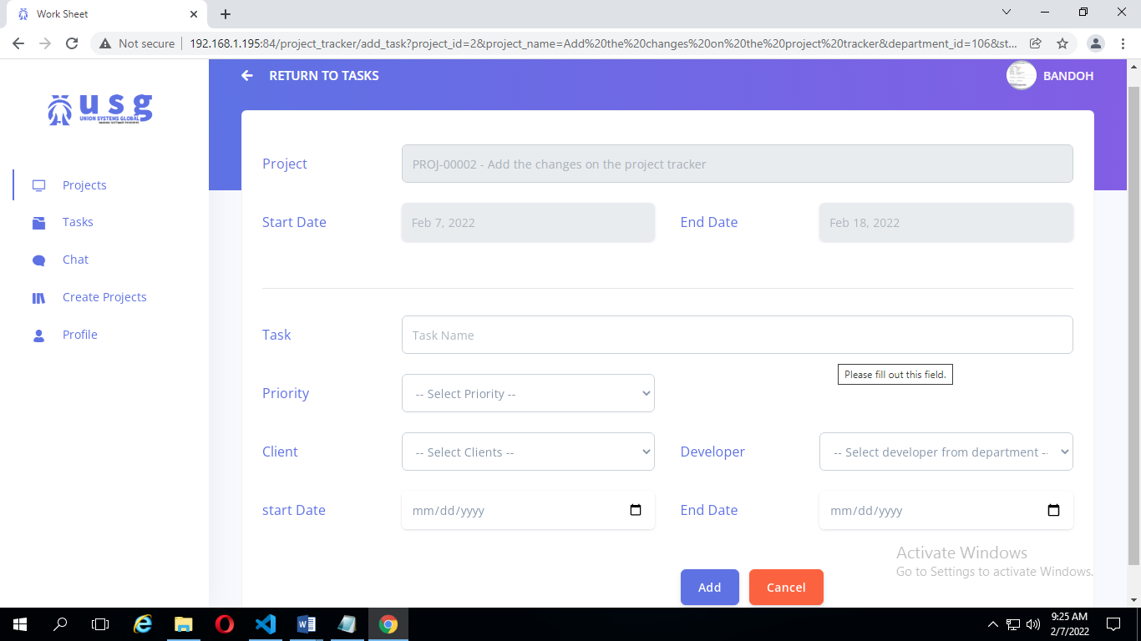

**The Developer:** This user has the ability to make updates on the tasks assigned to him/her by the assigner. This user also has the ability to change the status of the project which comes in four (4) stages thus not started, in progress, suspended and completed. The screenshot below is the dashboard of the developer.

**Screenshot for the developer’s dashboard**

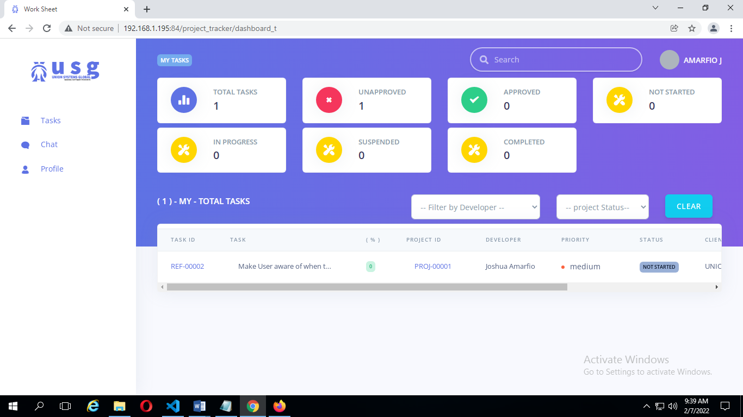

* Projects: This module is mainly about the management of the actions of projects in the project tracker. This module can be used to create, view and update project details which can be done by all users of any access right based. The projects module also has its status types as well, which includes drafts, unapproved, and approved. Below are the screenshots of operations under the projects module:

**Screenshot for the creation of projects**

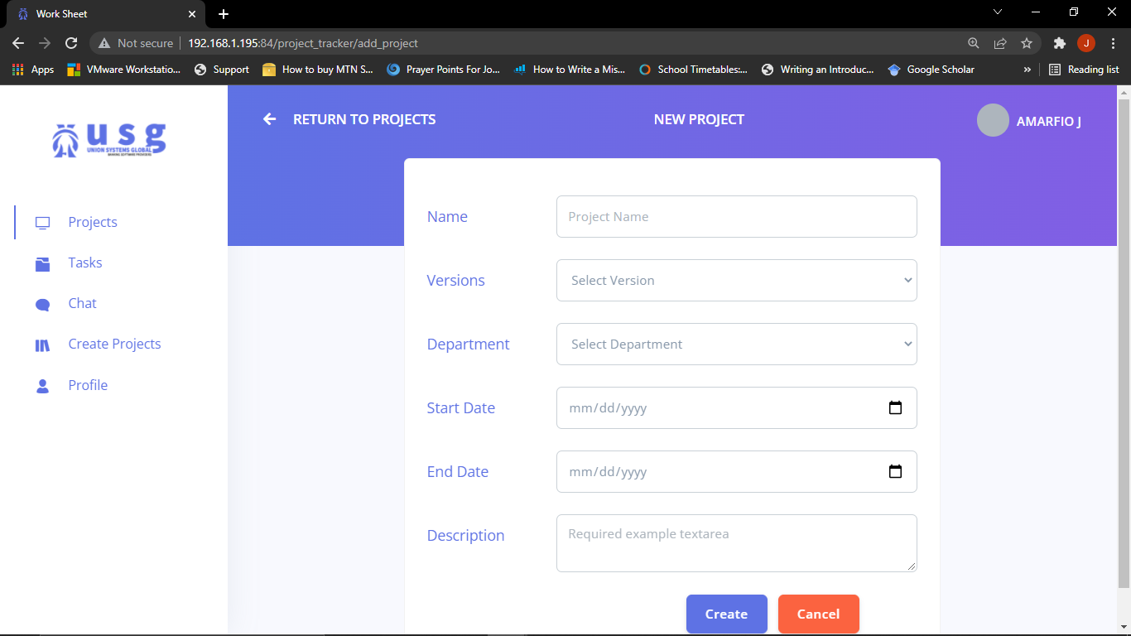

**Screenshot for project viewing**

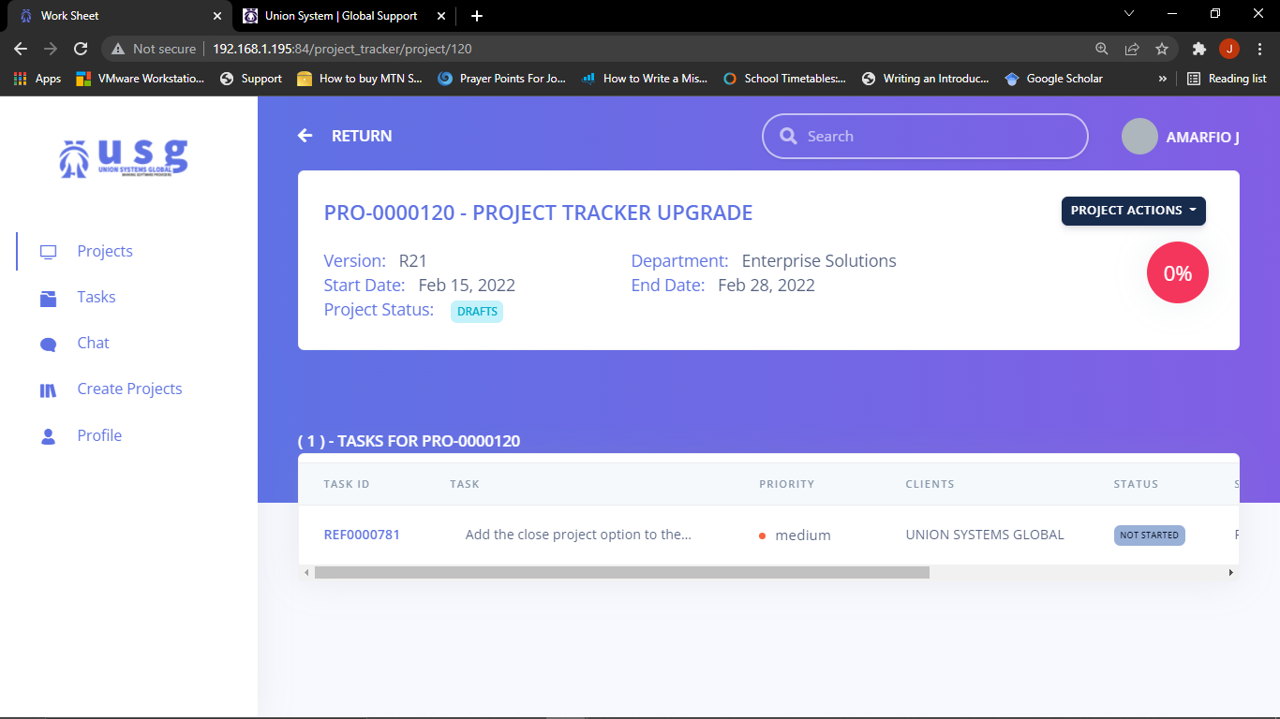

Now to edit the details of a project, kindly follow the instructions below:

* Click on the project actions at the top right corner



* Then click on edit project from the project actions drop down.

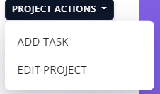

Below is the screenshot of what the edit project screen looks like:

**Screenshot of edit project:**

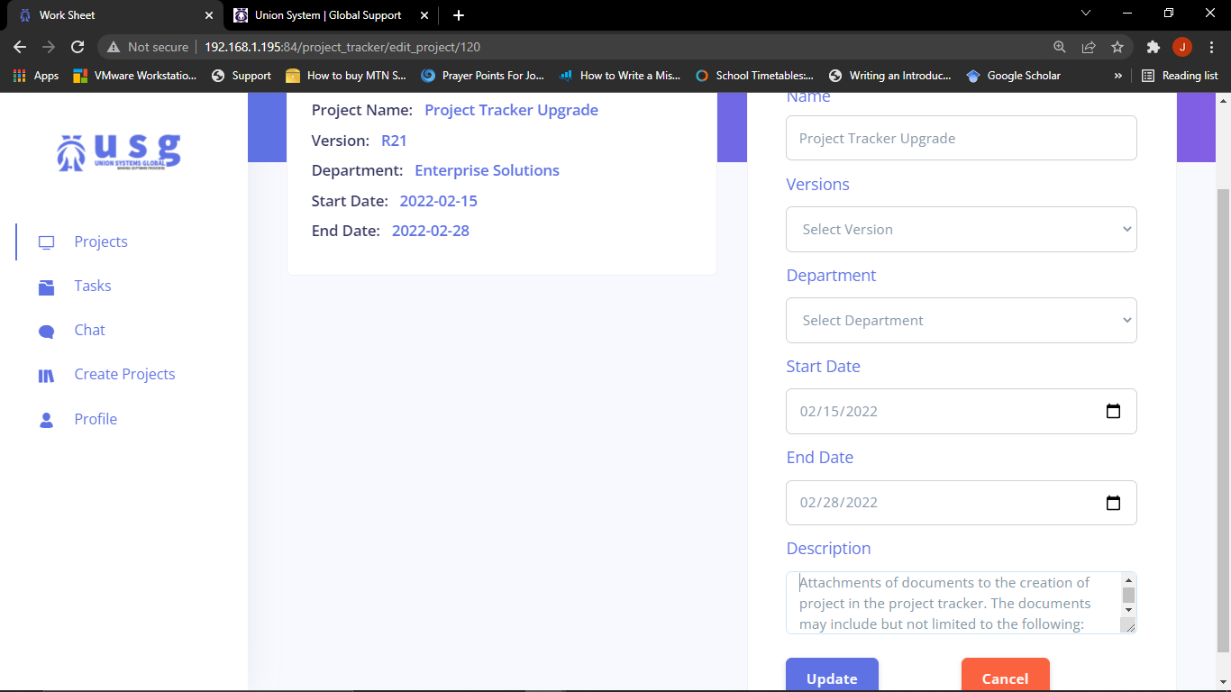

After the creation of projects, the application immediately opens the task screen where users are allowed to create tasks and also allow users to submit the project for approval. This means that if a project is created without a task, it can never be submitted for approval. Below is the screenshot for the creation of task:

**Screenshot of task creation screen:**

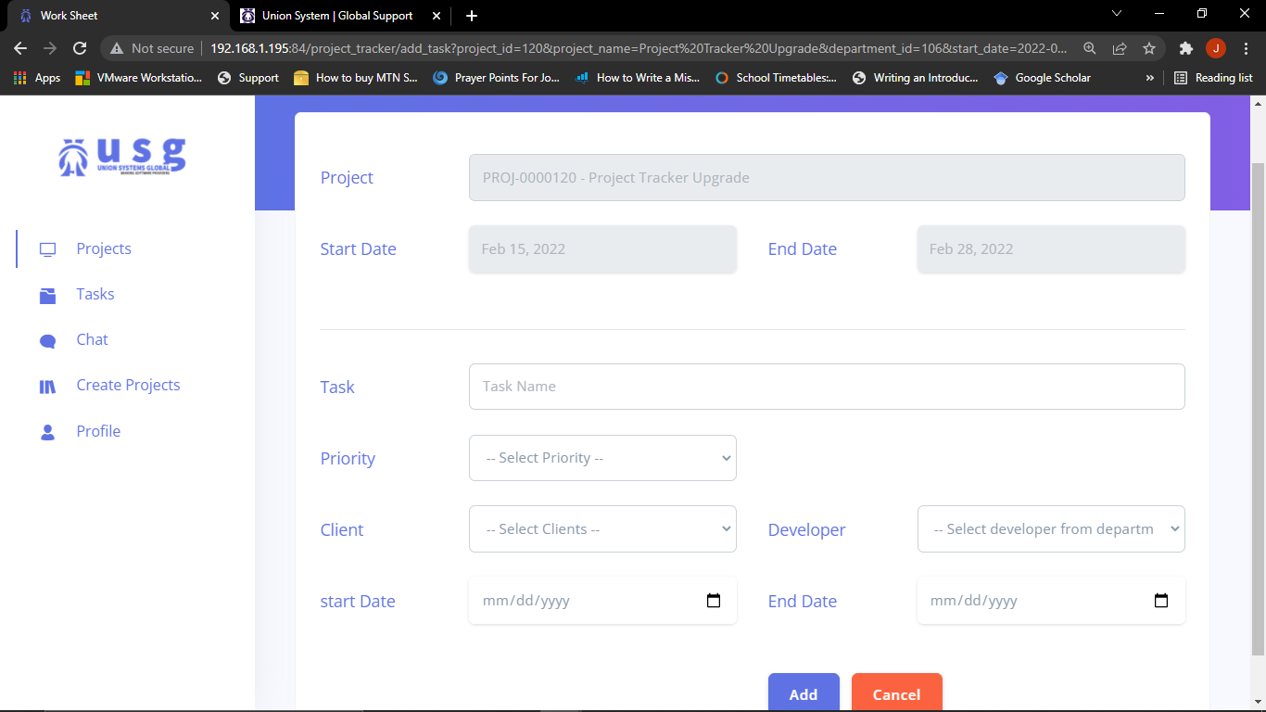

**Screenshot of a project with task included:**

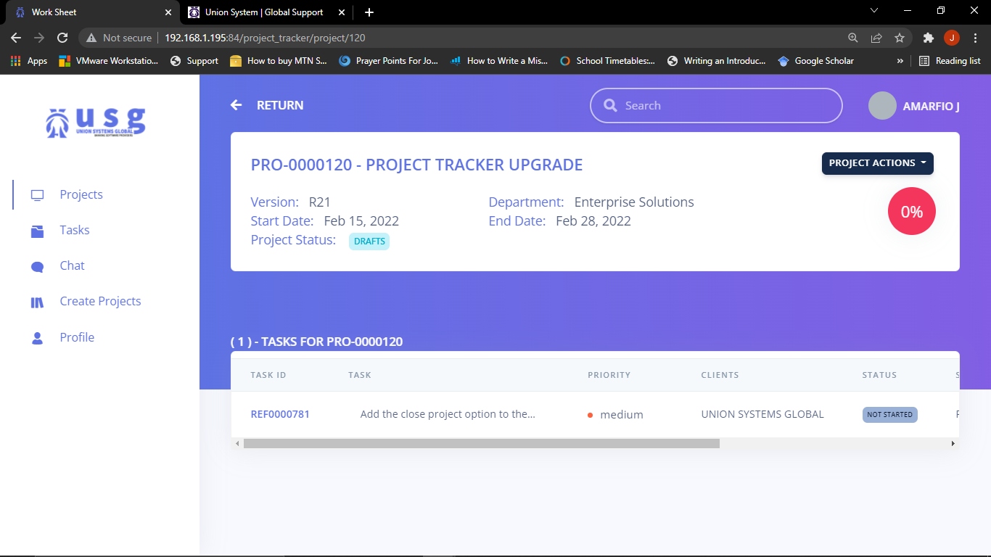

After the creation of task, now the project can be submitted for approval which is done by the head of the department who can approve.

Below is a picture indicating the **submit for approval**:

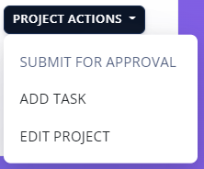

To save yourself from the stress of searching a list of projects on the dashboard, you can use the search field in the top right corner of the screen immediately you login to the application.

Below is a picture crop of what the search field looks like



This field is on the left side of your user name of the application. It is used to search through the list of projects logged in the tracker. Below is a screenshot of a search result:

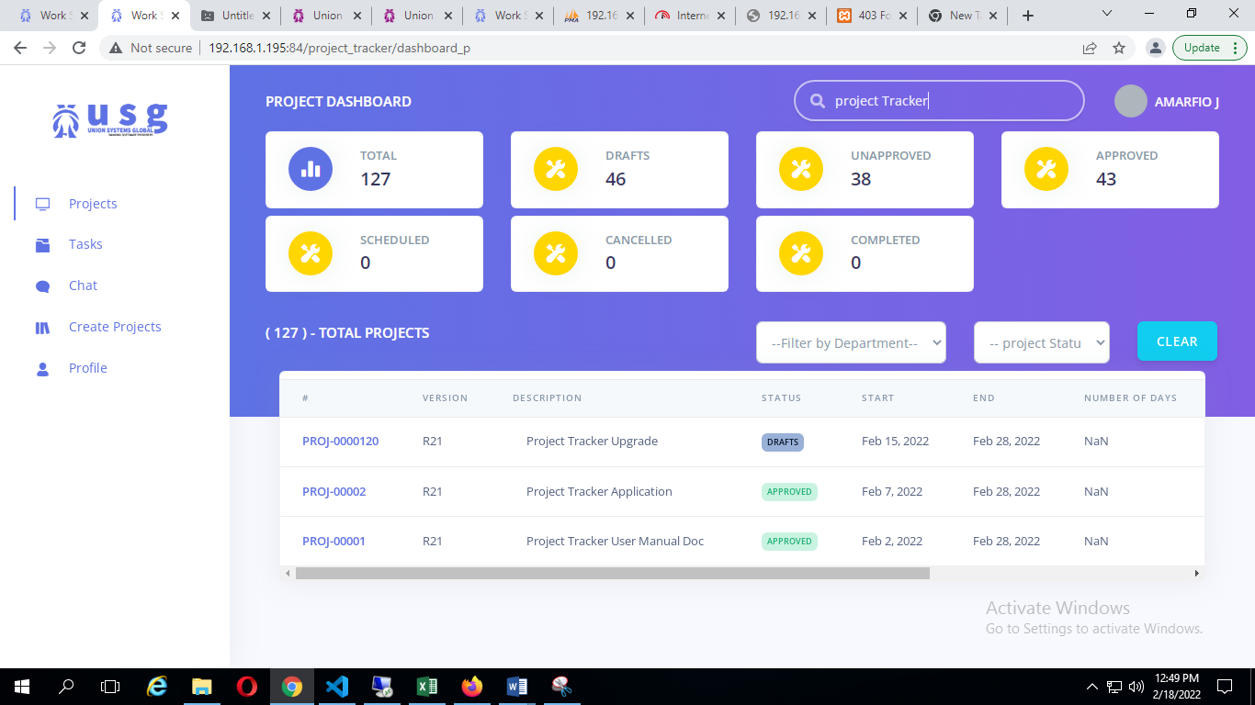

To give an update on a particular task, kindly following the instructions listed below:

In a project page, click on a particular task’s id number

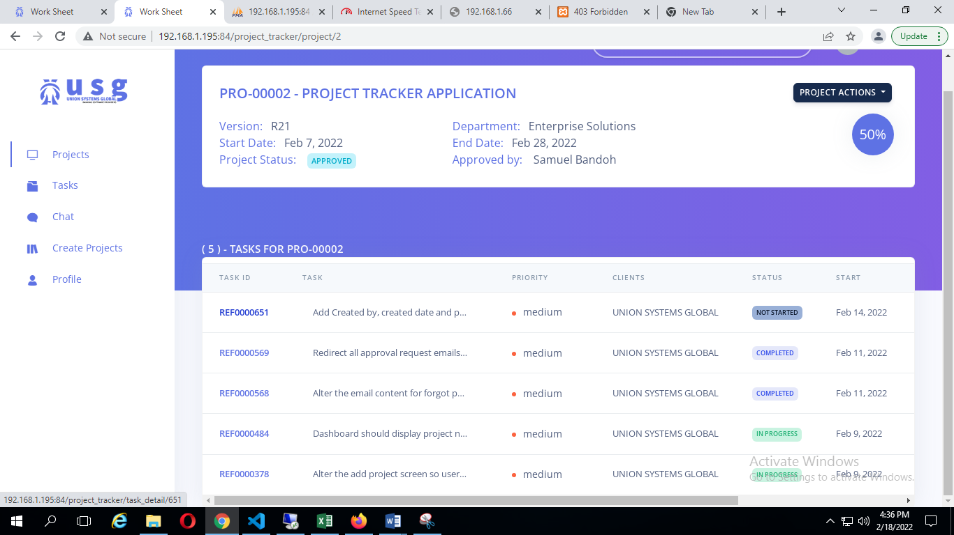

In a particular task page, there are status stages which includes the not started, in progress, suspended and completed which is a drop down.

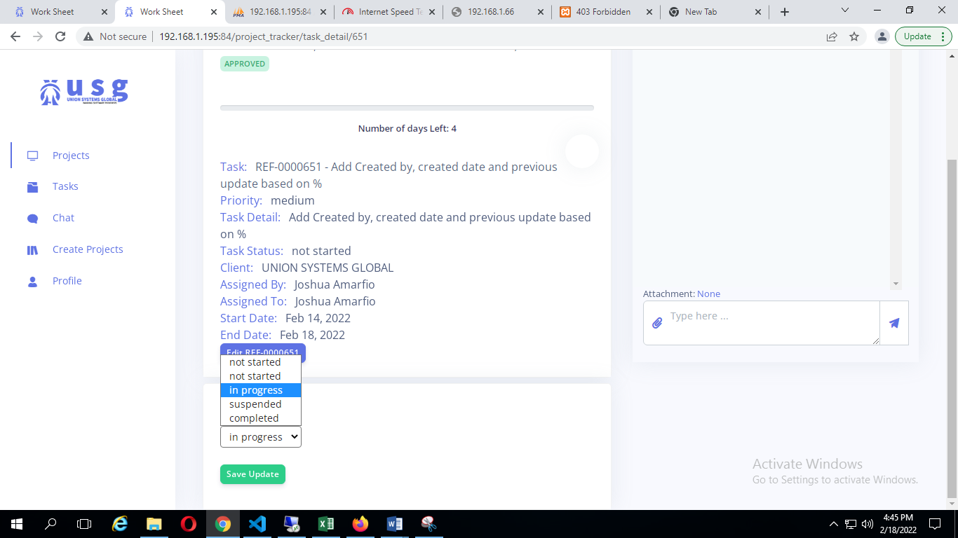

Click on a task status stage and click save update. After the save update button has been clicked, the page reloads and displays a screen indicating the status drop down, a go for testing button and completion drop down. The completion drop down helps to indicate the percentage of completion for the current task you are working on.

**Screenshot of task screen after the save button is clicked**:

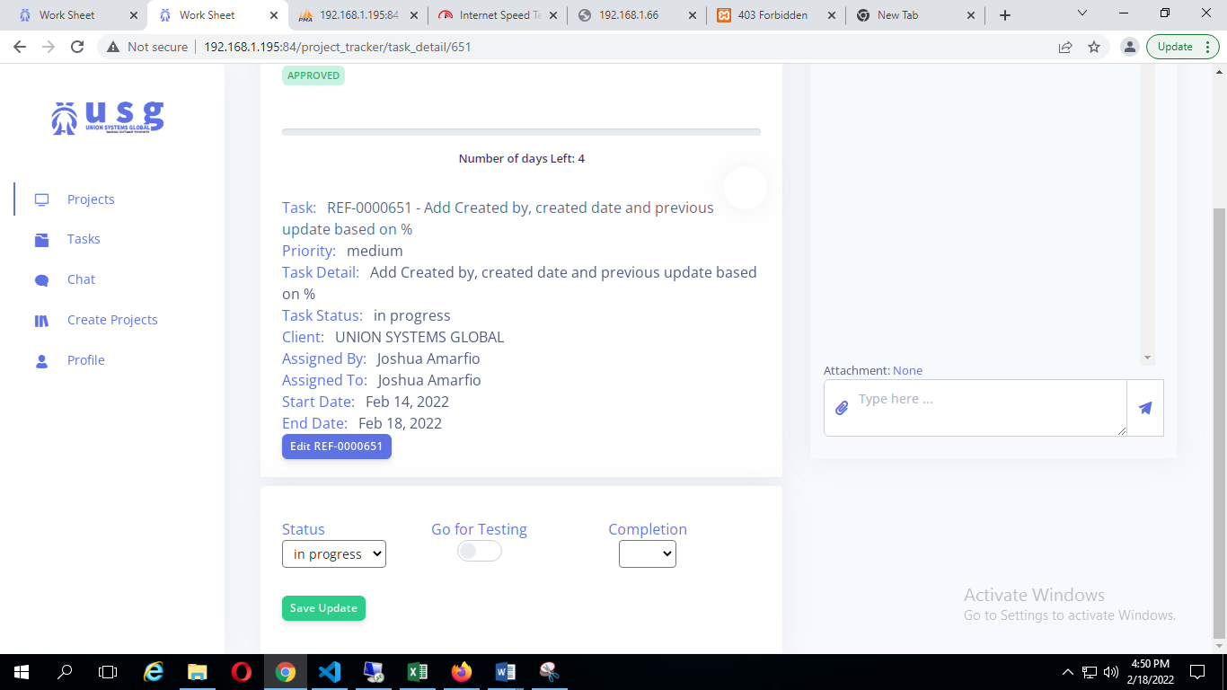

The range of completion of a task is indicated in the picture below thus from 10 to 100:

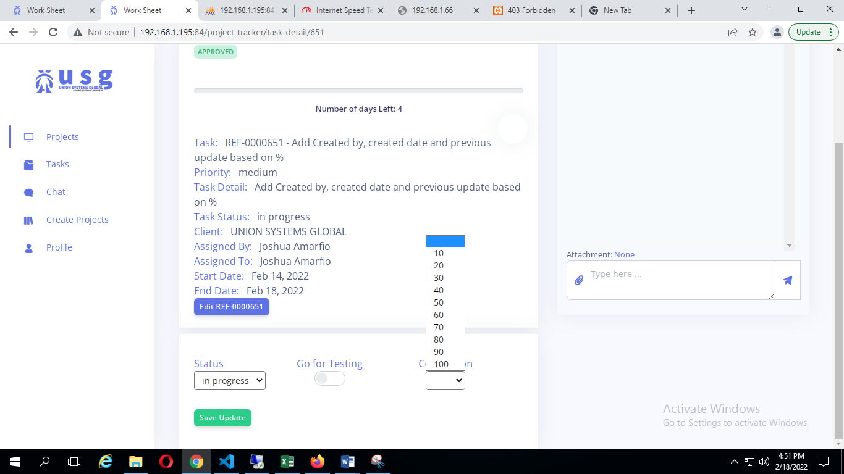

The percentage of completion to a task contribute to the overall percentage of completion to a project. And also the comment and updates section also allows to give more details on what was done on that particular task.

Type your task update text in the bottom right corner and press the send button.

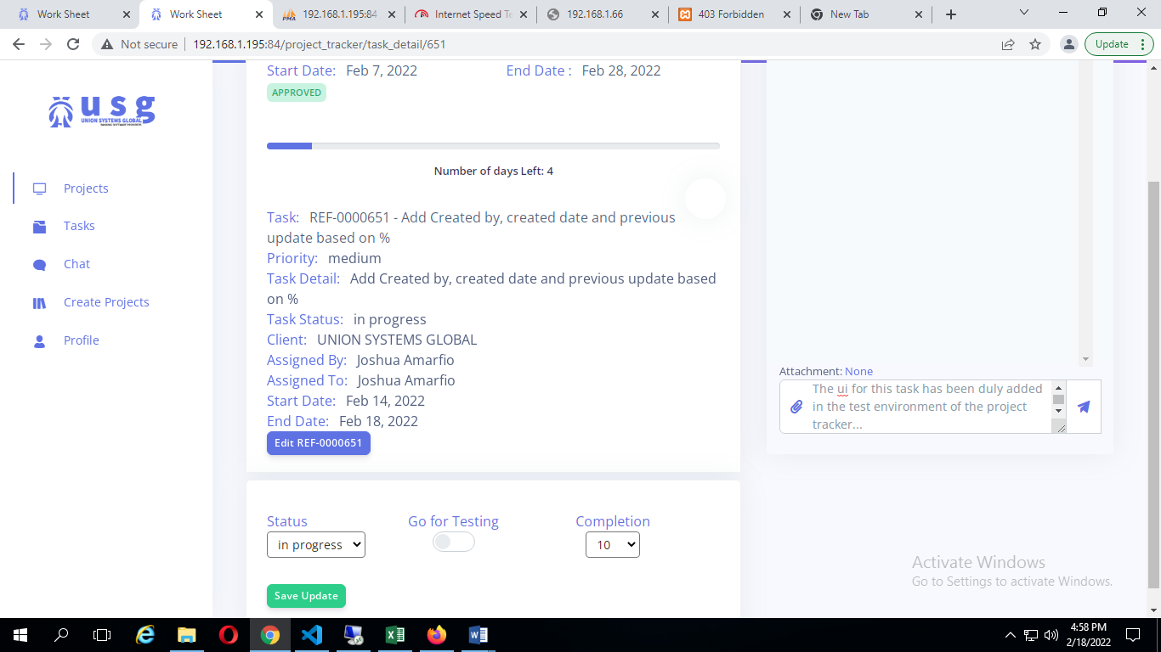

Aftermath for pressing the send button.

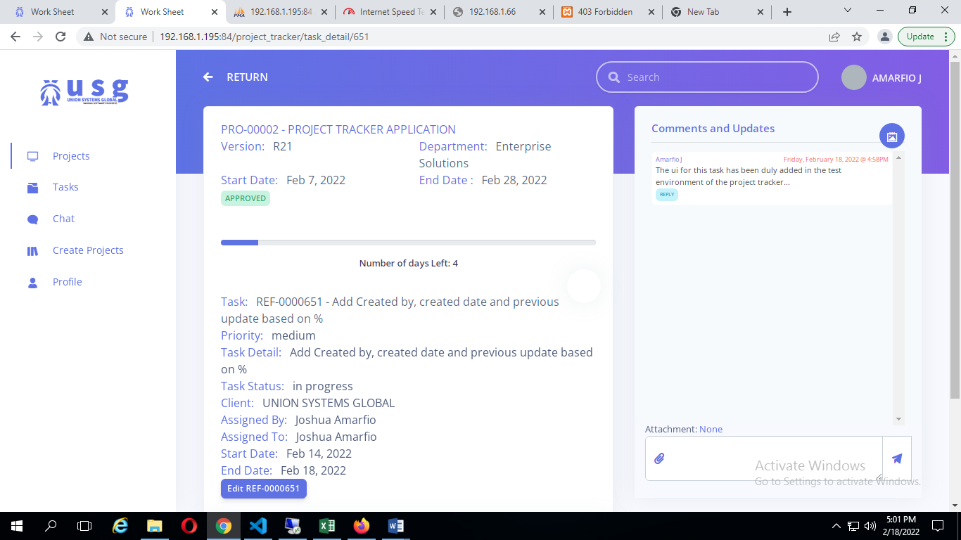

The comments and update feature also allows you to attach a document to the comment passed by using the attachment button. This is what its looks like when you attach a document to a comment.

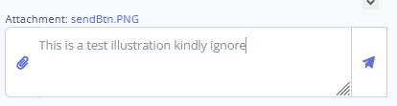

Always remember to give an update using the comment section on what has been done so far.

To access or download an attached document, kindly click on the attachment logo that is attached to the comment passed.

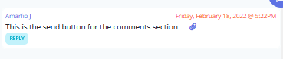

After clicking on that attachment(document) logo it downloads to the location you specify.

That’s the end for now. The tracker also provides us with the chat feature where we can share ideas on projects to be done and the tasks accordingly yeah.